First race of the season is in the books. The Colorado Cup went very well for the first race of the season and one of the hardest ones to start due to the mandatory start list to get individual times. Many people came up from the front range with some driving over 6 hours to compete. Many went out for a second lap following the race.

Next up is Tennessee Pass Night Jam. I will be touching base with Ty early in the week to make sure he has everything. Tamira and LRS are donating some beers for the cause.

I am meeting next week with GOL!’s ED Vanessa to speak about future collaboration efforts with their group. We used the GOL! Space for check in of the Colorado Cup Race and it worked out very well. We’ll probably do the same thing for the Fatty Patty.

Emma has been kicking butt on the website and she and I have been plugging away on it. It’s close to being publishable but still waiting on some pictures from Board members and short bios. I am happy to add embarrassing photos and make some bio up if you don’t get us anything soon.

I attended an IMBA Local open house webinar that highlighted some resources that we should all look at. Log into your imba.com using your membership info and click on chapter dashboard. This will show you some of the resources.

I spoke with Weezy the other day and she has decided to step away from the Wheelers in a paid role to focus more on her work at Melanzana. She will pass along any information that may be of use and also all info regarding the GOCO grant, Fox Grant, and Saris Grant.

I’ve been working on the map and the pictograms. I went down to Zero Day Coffee and Leadvelo with a large print of the mock up trail map and asked for feedback. Overall the response was great, with some very good feedback. I am making those tweaks this week to show everyone for Wednesday’s meeting.

I checked out the snowmobile that Steve Smith was wanting to fix up for the potential to groom on his property. Without a lot of money this snowmo is not worth putting any of our effort in.

We still have the classic track groomer that CMC lent us and after grooming Candyland the other day it dawned on me that we could add a classic loop on the outside of Candyland that we could groom easily while doing our normal route. This would add maybe 15 mins to the grooming process by requiring the groomer to switch attachments at the junction. The classic groomer would stay out in the woods.

I attended a webinar for the EPA RERC and EDA where they spoke about funding opportunities for communities that rely on outdoor recreation. There are some grants that might be suitable for us or the county to apply for in regards to recreation on the Eastside and potential planning funds. I plan to work together with other Trails Coalition participants to look into these.

On February 10th we’re having our first official board meeting for the Colorado Mountain Bike Coalition.

I received a quote from Eco Counter for a trail counter. I think this is a necessary piece for the club to provide funders and partners with data that supports our efforts. I believe I have matching funds to help make this happen from a donor.
https://www.eco-counter.com
Quote

I worked with Adam Ducharme early on a cold morning to get some footage for our trail etiquette video. Next step is to get footage of people riding, running, skiing, and postholing in inflatable suits.

I met with Becky Edwards to speak about the potential for funding from the Tourism Panel. Up to $5000 (per group) will be made available to aid in promotion of events. I am putting together a budget for The Wheelie Cool Gala for potential funding through the Panel.

Lots of Merch is in the works. Bottles should be arriving here this week. I’m working with Amber on shirts for Winter series to have available by MBT Mayhem. You all voted on socks, I think it would be nice to have 2 different pairs to offer. I’m working with Oveja Negra now for some custom bags and also with BOCO for a new winter beanie. Open to any other ideas for merch, like new jerseys, hats, and snap button shirts.

Fundraising Goal: Work with the Fundraising Coordinator to meet a development goal of $20,000 to cover operating costs and overhead. Support Fundraising Coordinator in finding and maintaining funding sources to cover the cost of projects through private funding, sponsorships, and grants.

- We received our $7500 match from Lifetime Foundation for the Outride Fund
- We have raised $640 through the Dig In Campaign so far towards the match goal of $2000
- Applied for a $5000 Grant with Network for Good.

Income Statement - Jan 1 to Dec 31 2021

Membership Goal: Retain and engage current members in projects, events, and other happenings in the club. Continue to seek out new members through community engagement.

- Current Members: 249- down 4 from last month

Trail Maintenance, development, and projects
Goal: Maintain the current trail system and develop new opportunities for trail expansion and special projects.

- Finished Trail Pictograms with Andy Lee.
- Trained 2 new Groomers- Katie Anderson and Whit Wilson.
- Groomed 7 times, now with Brian, Whit, and Katie all taking turns
- Draft Map
- Pictograms

Events
Goal: Manage/execute successfully virtual Winter Mountain Bike Series and plan/develop opportunities for the upcoming summer.

- First race went off without a hitch! 82 in person racers- 30 Self Timers
- 150 people have registered for the LWMBS- 72 for the Entire Series 15 for Tenn Pass and 63 for Colorado Cup
- Net Sales for LWMBS $7229.25
- I met with Tamira and Katie to discuss new events for the Summer and Fall. 10,152 race on the Timberline Trails and a fall triathlon event. Also discussed a long distance fat bike race.

Community Outreach/Engagement
Goal: Effectively communicate club activities with community members, businesses, and visitors to Lake County to increase awareness, support, and participation.

- Held another well received Lake County Trails Coalition Meeting
- Promoted Lake County Recreation Plan - https://lakecountysurvey.org

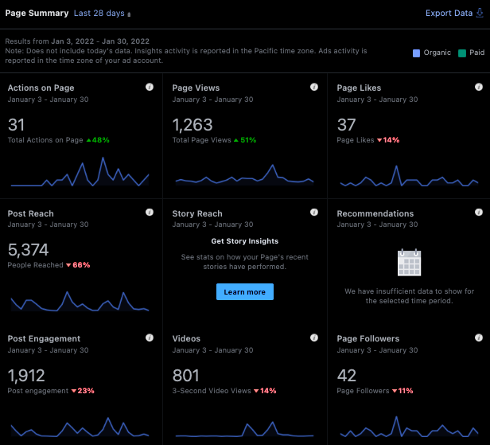

Instagram-

December- Accounts Reached 1925 +135% compared to nov
Accounts engaged 373 +92%
Audience 1108 +1.8%
16 posts 11 stories 4 videos

January- Accounts Reached 12,000 +491% compared to Dec
Content Interactions 643 +79.1%
Audience 1152 +3.1%
13 posts 22 stories 2 videos 3 Reels

Board Relations
Goal: Ensure board meetings are consistent and on track with goals therein.

Please look at your chapter dashboard on IMBA for resources including Board information

